InSpect and AutoSpect GUI
Instruction Manual

Dr. Andrew M. Crawford, PhD

28 October 2024

Version: 0

Introduction
This alignment GUI is designed to register elemental maps (e.g., from X-ray fluorescence imaging and Laser-Ablation-inductively-coupled-plasma-time-of-flight-mass-spectrometry imaging), histology, and other techniques for extraction of statistics.

General

Available Downloads

Mac (currently not available)

Windows
The Windows version of InSpect can be downloaded from the following site.

Linux (currently not available)

Data Storage and Access:

Data Storage
The current version of the InSpect software package stores the GUI data to a *.mat file native to MATLAB and also updates the stored data to the *.h5 file from the TOFWERKS instrument.

Data Access

Elemental Mapping

InSpect/AutoSpect
*.mat: The current version of the software can read the *.mat format files save directly from AutoSpect.

TOFWERK
*.h5: The current version of the software reads the *.h5 format directly from the S2, R, and 2R instruments from TOFWERK.

Graphical User Interfaces

Main User Interface
The main user interface has two main tabs: Drift Correction and Spectral Fitting ().

(TAB) Drift Correction
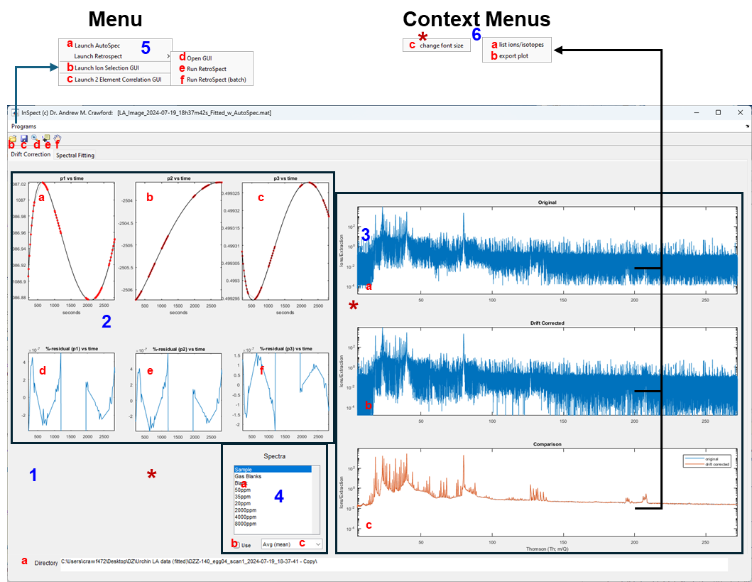
- Main background/panel of GUI
  - Directory where the data for the loaded scan is located
  - Load AutoSpect fitted data or InSpect session.
  - Save the current InSpect session. This amends the AutoSpect fitted file.
  - [toggle] magnifying glass – enables zoom for plots. This deactivates the Context Menus when selected.
  - [toggle] data point indicator – data point information. This deactivates the Context Menus when selected.
  - [toggle] pan – enables panning for plots. This deactivates the Context Menus when selected.
- Drift correction variables – measured and fitted values
  - P₁ drift corrected as a function of time
  - P₂ drift corrected as a function of time
  - P₃ drift corrected as a function of time
  - Residual of P₁ drift corrected as a function of time
  - Residual of P₂ drift corrected as a function of time
  - Residual of P₃ drift corrected as a function of time
- Drift corrected spectra
  - Original uncorrected spectra for all the partitions of the dataset
  - Drift corrected spectra for all the partitions of the dataset
  - Comparison of original and drift corrected spectra averages
- Selecting for different parts of the fitted data
  - Spectra: this allows the user to select the different parts of the file, i.e., Sample, Gas Blanks, individual References.
  - “Use” [checkbox] – Toggles whether or not to use the number of spectra listed in c.
  - [popupmenu] – the number of spectra to display for the part of the scan selected (a). If the user selects “Avg (mean)” then it takes the mean of each partition. 2: this will show the first and last partition of each group. 3: this will show the first, last, and middle partition for the selected group. N: shows the first, last, and N-2 equally spaced partitions from the group.
- Program [Menu]
  - Launch AutoSpect:
  - Launch Ion Selection GUI
  - Launch 2 Element Correlation GUI
  - [Launch Retrospect] Open GUI
  - [Launch Retrospect] Run RetroSpect
  - [Launch Retrospect] Run RetroSpect (batch)
- Context Menus
  - List ions/isotopes: this allows the user to draw a rectangle around an energy region and then lists the isotopes in the current lookup table available for fitting.
  - export plot: exports the plot so that the user can save it as an image.
  - change font size: This changes the font size for the GUI

(TAB) Spectral Fitting
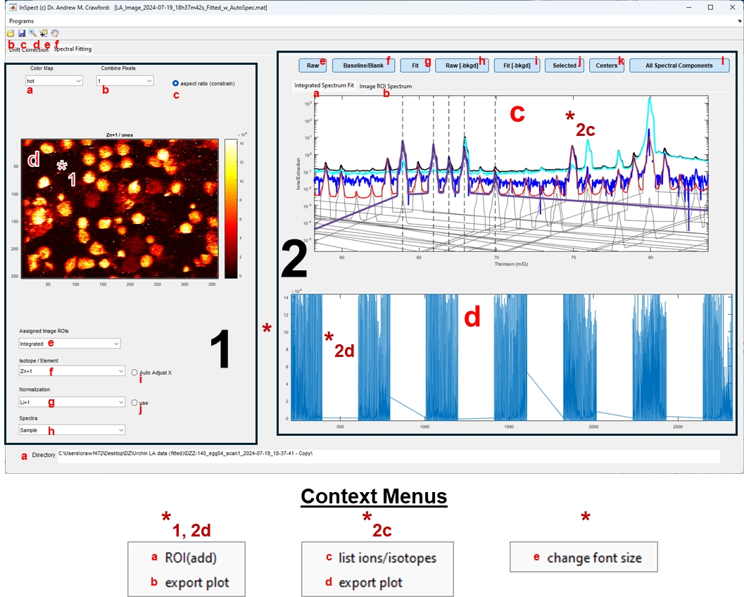

Supporting GUIs:

RetroSpect
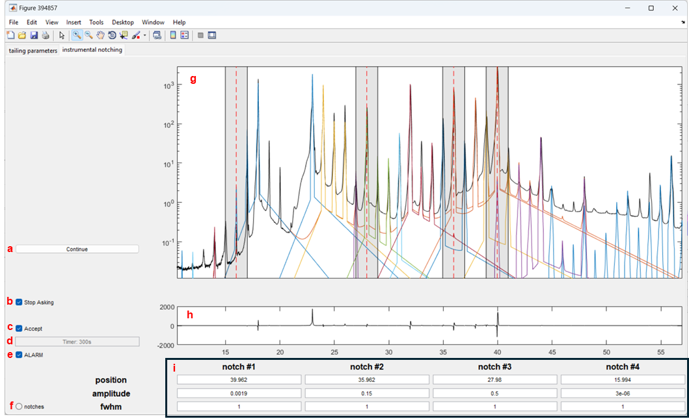

Isotope Selection GUI
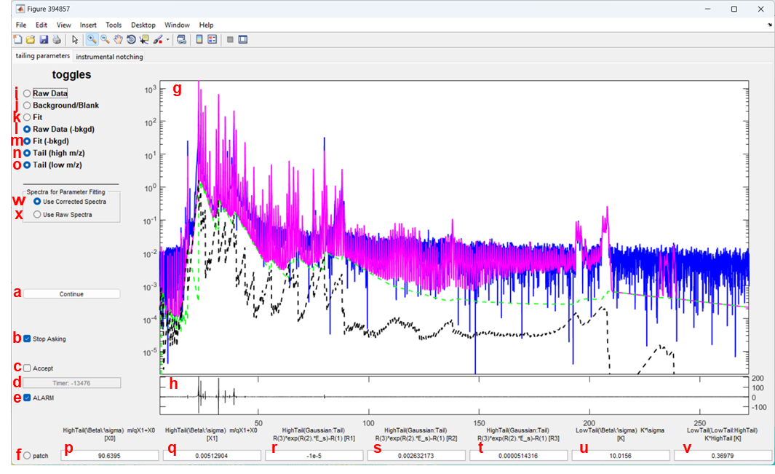

Processing Data

Loading a dataset

Fitting Datasets

Data diagnostics

